|  |  |
| --- | --- |
|  | **MINISTRY OF EDUCATION AND TRAINING** |

**FPT UNIVERSITY**

**CAPSTONE PROJECT DOCUMENT**

BSMS

**Report #2 – Software Project Management Plan**

|  |  |
| --- | --- |
|  | |
| Group Member | SE03975 - Olasehinde Ezekiel Olaoluwa |
| SE03444 - Kanda Joshua David |
| SE03520 - Shunom Peter Bala |
| Supervisor | Bui Đinh Chien |
| Ext. Supervisor |  |
| Project Code | BSMS |

- Hanoi, 05/2012 -

Table of Contents

1 PROBLEM DEFINITION 3

1.1 Name of this Project 3

2 PROJECT OVERVIEW 3

2.1 Project Description 3

2.2 Scope 3

2.3 Standard Objectives 6

2.4 Milestone and Deliverables 6

3 PROJECT ORGANIZATION 7

3.1 Software Process Model 7

3.2 Project lifecycle 7

3.3 Roles and Responsibilities 8

4 TOOLS AND INFRASTRUCTURES 9

4.1 Hardware 9

4.2 Software 9

5 SCHEDULE 10

5.1 Detailed Schedule 10

5.2 Meeting Schedule 11

5.3 Effort Estimation 12

6 RISK MANAGEMENT 13

7 CODING CONVENTION 14

# PROBLEM DEFINITION

## Name of this Project

The major aim of this project is to build a (BSMS) bookstore management system in-order to make management of book more easier by bringing it to the digital world, Book maintenances, information management and keeping track of data will be make much more easy with this concept.

# PROJECT OVERVIEW

## Project Description

Bookstore management system (BSMS) is one of a kind which is widely known for its popularity, this system is mostly used in any advance bookstore today. BSMS can help manage staff of a bookstore including books and it provides full access to end users whom we call the Customers, they can keep track of books, and even find book they are currently in production. Information of books like Author, Producers, Synopsis and many more will before more easily for customer to find. Also staff of our system can access content/Information management as well as the system admin.

## Scope

The scope of our project will strictly follow the following stages:

Developing:

* Software Requirement Specification
* Software Architecture and detailed design
* Implementation + Unit Testing
* Test case and Combination Test

|  |  |  |  |
| --- | --- | --- | --- |
| **No** | **Function** | **Sub-Function** | **Description** |
| **1** | Authentication Management | Login | Logging into the system |
| Logout | Signing out of BSMS |
| Register Customer | Guest registration to be become a customer |
| Register Staff | Registration of Staff users |
| Forget Password | Process of recovering lost password or reset |
| **2** | Category Management | Create Category | Creating new category in our system |
| Edit Category | Editing/Updating existing category |
| View Category | List all existing categories |
| Delete Category | Remove existing category from the system |
| View Books | View all book under a particular category |
| **3** | Genre Management | Create Genre | Creating new genre in our system |
| Edit Genre | Editing/Updating existing genre |
| View Genre | List all existing genre |
| Delete Genre | Remove existing genre from the system |
| View Genre | View all book under a particular genre |
| **4** | Staff Management | Create Staff | Create new staff |
| View Staff | View all staffs |
| Update Staff | Update staff information |
| Delete Staff | Delete staff from the system |
| **5** | Book Management | Add Book | Adding new book to the system |
| Edit Book | Edit existing books information |
| View Book | N/A |
| Delete Book | Delete book completely from the system |
| Read Online/Download | Read free books online or download the softcopy file |
| **6** | Wish list Management | Add to wish-list | Adding new books to wish-list directory |
| Remove from wish-list | Removing books from wish list directory |
| **7** | Profile Management | Edit Profile | User can use this feature to edit his/her own private information on the system |
| Change Password | Changing of password |
| **8** | Author management | Add Author | Add new author information |
| View Author | View author information |
| Update Author | Edit author information |
| Delete Author | Completely remove author from the system |
| View Book | View book by a particular author |
| **9** | Producer Management | Add Producer | Add a new producer |
| View Producer | Check producer information/profile |
| Update Producer | Edit producer information |
| Delete Producer | Remove producer information from the system |
| View Book | View book produced by a particular producer |
| **10** | System Search | Simple Search | Search book by name or synopsis. |
| Advance Search | Search the system for information. Book, Author, Producer, …… etc. |

## Standard Objectives

|  |  |  |  |
| --- | --- | --- | --- |
| **Metrics** | **Unit** | **Committed** | **Actual** |
| **Start Date** | dd-mm-yyyy | 14-May-2017 | N/A |
| **End Date** | dd-mm-yyyy | 14-Aug -2017 | N/A |
| **Duration** | Elapsed days | 102 days | N/A |
| **Team Size** | Number | 4 | 3 |

## Milestone and Deliverables

|  |  |  |  |  |
| --- | --- | --- | --- | --- |
| ***No*** | ***Deliverable*** | ***Committed*** | ***Actual*** | ***Deviation*** |
| **1** | Report #1 – Introduction | 21-May-2017 | 21-May-2017 | 0 days |
| **2** | Report #2 – Project Management Plan | 4-June-2017 | 4-June-2017 | 0 days |
| **3** | Report #3 – SRS | 10-June-2017 | 10-June-2017 | 0 days |
| **4** | Report #4 – Detailed Design V1.0 | 25-June-2017 | N/A | 0 days |
| **6** | Report #5 – Test Report V1.0 | N/A | N/A | 0 days |
| **7** | Report #6 – Manual | 16-Jul-2017 | N/A | 0 days |

# PROJECT ORGANIZATION

## Software Process Model

Our web application development phase will be implemented using the V software development process model. Our application will go through continuous updating following the V model format until final success of our project.

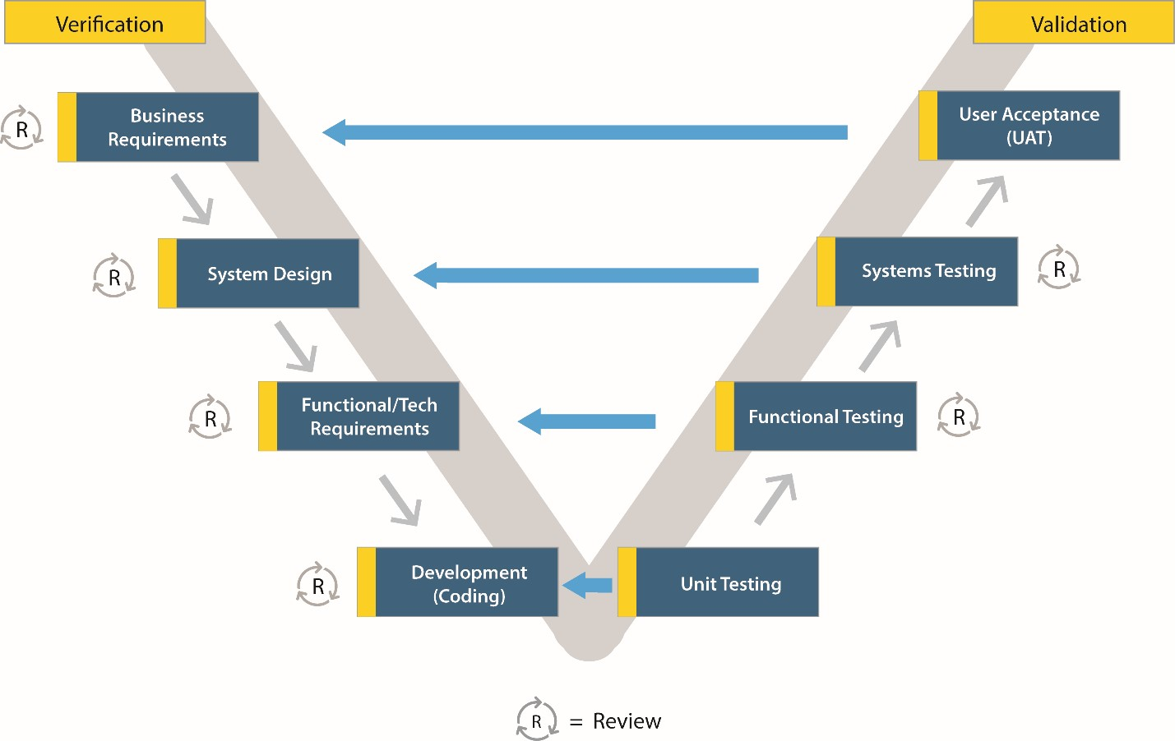

Why use the V-Model:

* Simple and easy to use.
* Testing activities like planning, test designing happens well before coding. This saves a lot of time. Hence higher chance of success over the waterfall model.
* Proactive defect tracking – that is defects are found at early stage.
* Avoids the downward flow of the defects.
* Works well for small projects where requirements are easily understood.

## Project lifecycle

|  |  |
| --- | --- |
| **1st Iteration** | |
| **Task** | **Description** |
| **Project Definition** | This happen as the beginning of everything, as all the team members collide to come with a project, and define what are the required features of our system. |
| **System Requirement Definition** | This module is where we will define in detail, the user requirement and how to implement them. |
| **Analysis and Design** |  |
| **Implementation and Manual** |  |
|  |  |

|  |  |
| --- | --- |
| **2nd Iteration** | |
| **Task** | **Description** |
| **System Requirement Definition** | This module is where we will define in detail, the user requirement and how to implement them. |
| **Analysis and Design** |  |
| **Implementation and Manual** |  |

## Roles and Responsibilities

|  |  |  |
| --- | --- | --- |
| **Team Member** | **Project Management** | |
| **Olasehinde Ezekiel Olaoluwa** | Role | Responsibility |
| Team Leader,  Developer  Tester  Database Engineer | Manages the team, and develop the system, Project manager of our system, The team leader goes will all function Testing, Development, Database Engineer, Design |
| **Shunmon Peter Bala** | Designer,  Developer | User interface designer, and support in implementation process |
| **Joshua David Kanda** | Database Engineer  Tester | Database Engineer, based on the database, he will have to manage anything relating to database engineering |

# TOOLS AND INFRASTRUCTURES

## Hardware

* Personal Computers for development with minimum configuration of :
* Core i3 4th generation 2.0 GHZ of Processor Speed
* 4GB of Ram
* At least 250 GB of hard disk space

## Software

* Operating System
* Windows 10
* Framework
* .Net Framework 4.0
* Angular JavaScript framework 4
* Front-End Framework Bootstrap 3/4
* Development Language
* JavaScript
* MSSQL
* C# (#=”Sharp”)
* Razor (CSHTML)

# SCHEDULE

## Detailed Schedule

|  |  |
| --- | --- |
| **N/O** | **Duration** |
| **Iteration 1** | 10 Weeks |
| **Iteration 2** | 4 Weeks |

|  |  |  |  |  |  |  |
| --- | --- | --- | --- | --- | --- | --- |
| **Task** | **Description** | **Output** | **Deliverable** | **Resource needed** | **Dependency** | **Risk** |
| **SRS** | Defining system requirement specification | SRS document – Report 3 | 20-May-2017 | All Group Members | None | N/A |
| **Database Design** | Designing Database Tables and attributes | SQL Queries | 22-May-2017 | 1 Member | SRS | Database requirements tends to change during implementation |
| **Software Design Description** | N/A | Report #4  Software Architecture and Design document | 15-June-2017 | 3 Members | SRS and  Database Design |  |
| **UI Design** | Interface design for BSMS | Report #4 | 20-June-2017 | 2 Member | Report #4 | Design might change in SAD report 4 |
| **Implementation and Unit testing** | Coding section | Implementation according to SRS | 21-June-2017 | 2 Member | SRS | SRS document is subjected to future change |
| **System Testing** | Testing the system to be sure if its officially working correctly | Test Report #6 | 15-July-2017 | All Team Members | SRS | SRS document is subjected to future change |
| **Deployment** | Publishing of our web application to the internet | N/A | 17-July-2017 | 1-2 Member | Implementation |  |
| **User Manual** | Creating a manual for end-users to understand the application | User manual Document | 20-July-2017 | 1 member | Implementation |  |

## Meeting Schedule

|  |  |  |  |
| --- | --- | --- | --- |
| **Subject** | **Capstone Project** | **Date** | **Every Saturday** |
| **Facilitator** | Fpt University | **Time** | 10:30 |
| **Location** | Fpt University campus high tech park, Hoa Lac | **Scribe** | Joshua David Kanda |
| **Attendees** | Supervisor | | |
| Olasehinde Ezekiel Olaoluwa | | |
| Shunom Peter Bala | | |
| Joshua David Kanda | | |
| **Absentee** | Olalekan Savage | | |

# RISK MANAGEMENT

|  |  |  |  |  |
| --- | --- | --- | --- | --- |
| **NO** | **Risk Description** | **Probability** | **Effect** | **Strategy** |
| **People Risk** | | | | |
| **1** | Misunderstanding between team member can occur | High | Intermediate | Fix misunderstanding between team member to make the project flow continue |
| **2** | Team member have different schedule | Low | Basic | Get all team members schedule and find suitable time to assign task |
| **3** | Team members cannot meet task deadline | High | Advance | Push deadline forward and make plan that allow team member to work overtime inorder to finish before the next deadline |
| **Technical Risk** | | | | |
| **4** | Team members might not be versatile with the technology we are using in our system | High | Intermediate | Change plan to use technology that team members are familiar with. |
| **5** | Team member do not understand the scope of the problem or do not fully understands the Requirement | High | Serious | Explain project scope and requirement to team member in more detail |

# CODING CONVENTION

Coding convention in our web application will strictly follows the camel case throughout, from the web services to the backend to the unit testing will strictly follow this rule.



Camel case (stylized as camelCase or CamelCase; also known as camel caps or more formally as medial capitals) is the practice of writing compound words or phrases such that each word or abbreviation in the middle of the phrase begins with a capital letter, with no intervening spaces or punctuation. E.g. someone whose name is “Nguyen Huy” in camelCase we will write it like this “nguyenHuy”, this coding convention will be followed throughout all of our system.